ALCUNI ESEMPI DI METOLODOGIE SEMPLICI PER L’ESTRAZIONE DI DNA

Nome esperimento | Frullato di DNA (estrazione del DNA da kiwi o pesca)
Disciplina/e | Biochimica
Tema affrontato | Visualizzazione DNA da alimenti
Età studenti | 10-16
Tempo necessario | 1 unità oraria
Grado di difficoltà | 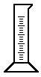
Attrezzatura e materiali | 10 ml di detersivo liquido da cucina, 3 g di sale fino da cucina, 100 ml di acqua distillata, mezza pesca o kiwi, 20 ml di etanolo freddo al 95% (alcol per preparare liquori), imbuto, frullatore ad immersione, carta da filtro, 2 becher (bicchieri), 1 cilindro graduato da 100 ml, 3 provette grandi tipo Falcon, ansa (un filo metallico con una estremità ad occhiello), coltello
Protocollo | 1) spezzettare mezza pesca o kiwi  2) unire nel becher sale, detersivo, ed acqua distillata e mescolare bene  3) unire il frutto a pezzi  4) attendere 10 minuti  5) frullare bene per 5 secondi  6) filtrare il frullato  7) versare 20 ml del filtrato in una provetta  8) unire molto lentamente l’alcool etilico facendolo colare lungo la parete del becher finché non appaia il precipitato bianco e filamentoso del DNA  9) raccogliere i fili di DNA con un’ansa roteando in un unico senso
Materiali didattici | Scheda di laboratorio con domande di verifica  Sito web con altri protocolli di estrazione del DNA:  http://learn.genetics.utah.edu/units/activities/extraction/  Modellini di DNA da costruire ( di cartoncino, origami, di liquirizia e caramelle marshmallow)  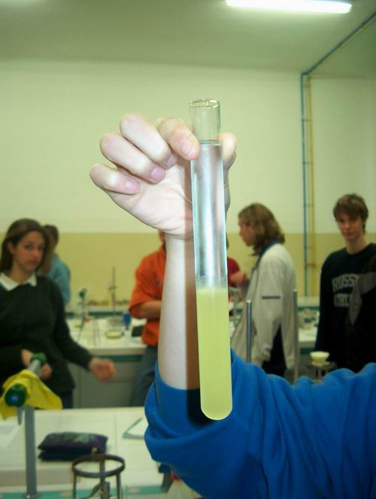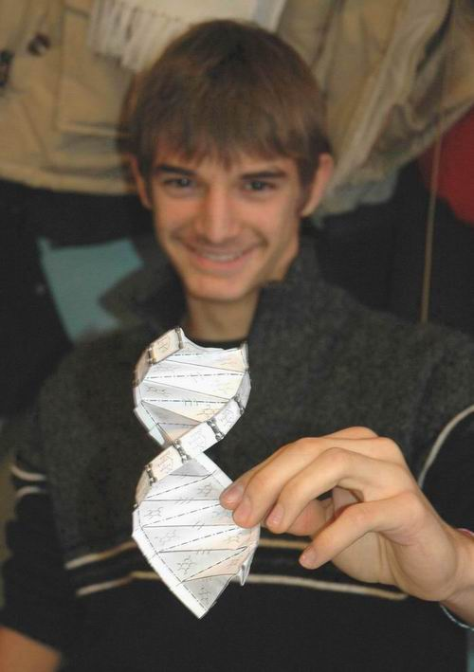

Nome e Cognome …………………………………………………….
Classe …………………………… Data …………………………….
Scheda di laboratorio: Estrazione del DNA di kiwi

Fa’ un segno (V) nella casella corrispondente ad ogni fase di lavoro eseguita:

1-Spezzettare un kiwi
2-Unire nel becher sale, detersivo, acqua distillata e mescolare bene
3-Unire il kiwi a pezzi
4-Attendere 10 minuti
5-Frullare bene per 5 secondi
6-Filtrare il frullato
7-Versare 20 ml del filtrato in una provetta
8-Unire molto lentamente l’alcool etilico facendolo colare lungo la parete del becher finché non appaia il precipitato bianco e filamentoso del DNA
9-Raccogliere i fili di DNA con un’ansa roteando in un unico senso

Rispondi alle seguenti domande:

- in quale parte del frutto si trova il DNA?
…………………………………………………………………………………………………………………………………………………………………………………………………………

- Secondo te a cosa servono il detersivo, il sale ed il trattamento con il frullatore?
……………………………………………………………………………………………………………………………………………………………………………………………………………………………………………………………………………………………………………………………………………………………………………………………………………………

- Perché il precipitato di DNA si presenta filamentoso?
………………………………………………………………………………………………………………………………………………………………………………………………………………………………………………………………………………………………………………
……………………………………………………………………………………………………

- In quali oggetti o sostanze puoi trovare del DNA?
………………………………………………………………………………………………………………………………………………………………………………………………………………………………………………………………………………………………………………

- In quali oggetti o sostanze NON puoi trovare del DNA?
………………………………………………………………………………………………………………………………………………………………………………………………………………………………………………………………………………………………………………

- Vuoi esprimere qualche osservazione sull’esperienza che hai fatto oggi?
………………………………………………………………………………………………………………………………………………………………………………………………………………………………………………………………………………………………………………
TAKE HOME ACTIVITY:
DNA extraction from bananas
PROTOCOL
1. Squash a small piece of banana (2-3 cm) with a fork
2. Pour 12 ml extraction buffer1 into a beaker- this buffer contains salts necessary
for the precipitation of the DNA. Add 3ml detergent which will break open the
cells

What is the purpose of the detergent and of the salt solution in the beginning step?
The detergent dissolves the lipids that hold the membranes together and this
releases the DNA into the solution. The detergent further causes lipids and proteins
to precipitate out of the solution, separating them from the DNA. Shampoo or
washing liquid can be used.
The salt in this first step enables the DNA strands to come together and aggregate.
3. Add the banana pulp and mix well
4. Put two layers of paper tissue into a funnel and moisten with water. Pour the
banana mixture into the funnel and, collect the filtrate in a conical flask. Throw
away the filter paper with the remains of the banana pulp.
5. Put 1ml of the filtered banana juice into a plastic tube
6. Add 1ml of distilled water and mix well
7. Carefully pour 8ml cold alcohol down the side of the tube so that the alcohol
remains in a layer above the juice (Here the concept of density can be
reinforced! With a lower density, the alcohol will ‘float’ on top of the juicy
solution. When performing the experiment, ask the students to predict what will
happen given the density of the two liquids)
8. Let the solution sit for 2-3 minutes. You can watch DNA precipitate out into the
alcohol layer. A white substance will become visible at the interface where the
two liquids meet-this is the DNA!!!
The alcohol precipitates DNA. DNA is not soluble in alcohol. When alcohol is
added to the mixture, the components of the mixture, except for DNA, stay in
solution while the DNA is precipitated.
9. When good results are obtained there will be enough DNA to be lifted out of the
tube with a hooked Pasteur pipette or a hooked paper clip.
10. After the experiment, the extracted DNA can be taken home in a small
Eppendorf tube containing some alcohol

1 8.8g NaCl and 44g Sodium Citrate in 1l water, but eventually kitchen salt would work!!!

Extracting DNA
DNA, deoxyribonucleic acid. It occurs as a double-stranded giant molecule, whichcontains replicating bases, ribose sugars and phosphoric acids. DNA contains a three base series, in which each base contains instructions for amino acids.
Amino acids combine to produce proteins in the cell. A set length of DNA is, therefore, an entire protein production model, called a gene.
DNA can easily be extracted from many living organisms and tissues. In this activity, first, we break the cell structure by breaking down the cell and nuclear membranes. Through enzyme handling, proteins and insoluble carbohydrates are broken down and precipitated from the solution. The last step is to use alcohol in order to precipitate the DNA from the water solution, and to gather the DNA for study.

Where do we find DNA?
In hair? In blood? In skin? DNA can be found in all organic substances: in the wooden Swap Shop table, in mummies, and even, to some extent, in fossils. A cell is the basic structure and the smallest unit of life. DNA is found in the control centre of the cell, called a nucleus. Viruses are actually smaller than cells, but they cannot exist without cells and DNA. DNA is packaged in the nucleus as chromosomes. In one human cell, there are approximately 2 meters of DNA!

Activity:
-Remove the dry outermost layers and hard base of the onion. Chop the onion into pieces using a knife.
-Place the chopped onion into the 250 ml glass dish. Pour preheated wash liquid over it until it is completely covered. Stir it with the sturdy glass rod.
-Place the dish in water at +60 C for about 15 minutes, mixing occasionally with the glass rod.
-Place the dish in a freezing bath and speed the cooling process by mixing occasionally with the glass stirring rod.
-Strain the filtrate through a coffee filter. Keep the filtrate as cold as possible.
-Pour about 20 ml of filtrate into a container. Using a plastic pipette, slowly pour alcohol over the sample, making sure that you pour in at least as much alcohol as there is sample fluid in the tube, and that the alcohol is as cold as possible. Do not mix!
-Using a toothpick, collect the DNA which coagulates at the interface between the sample fluid and the alcohol.

The cell model of an onion
The largest cell in a human is an ovum, 0.1 mm. Generally, cells are microscopically small.

Cardboard box = cell wall
A cardboard box is made of cellulose, just like the cell walls of a plant cell. Animal cells do not have cell walls.
A cell wall is porous, allowing the detergent and the salt ions of the wash solution to pass through it.
Part of the cell wall has already broken down during the process of cutting and mixing.

Canister = cell membrane
This is the outer surface of the cell, and a part of all cells.
Its purpose is to channel information, nutrients and waste.
Its structure is well protected by projections, composed, for example, of proteins.
The membrane is flexible and is made up of lipids, or fatty substances.
The warm water and the detergent of the wash solution dissolve the cell membrane.

Internal structures

Plastic bag = membrane structures
The membrane structures take up most of the space in the cytoplasm.
The membranes divide the internal structure so that each process in the cell has its own area.
Most of the cell activity occurs in the membrane structures.
The wash solution has also broken down these membranes.

Bag containing peas = coarse membrane
These are the granules in the membrane. They are called ribosomes and they handle protein synthesis (manufacturing).

Balloon = vacuole
This is a large membrane-bound vesicle, consisting of a double lipid membrane.
It is the storage for excretions such as waste or hormones, which are then transported through the outer membrane.

Rubber glove = dictyosome
This is equivalent to the Golgi apparatus of animal cells.
This is a production unit, and is formed by consecutive membranous sacks.
Various production processes occur in these sacks.

Straws = pipe structures
These are the structural scaffolds, the support structures and transference channels for various substances.

Rubber bands = filament structures
These enable the cell to stretch and contract.
The ability to stretch and contract is necessary for processes such as cell division (nuclear spindle; divides chromosomes).
Muscle cells contain an enormous amount of filaments formed by actin and myosin.

Yellow styrofoam flakes = starch
This is the most important reserve nutrient in a plant cell.

Fire alarm = alarm system
This is reserved for emergency situations. Threatening situations might be, for example, an increase in heat, which will solidify proteins, or a change in the chemical make-up of the cytoplasm, which can lead to poisoning or viral penetration into the cell. In this case, a special alarm system activates a virus defence.

Solar cell = chloroplast
Centre of photosynthesis: In the chloroplast, light energy helps in the production of sugar and oxygen from water and carbon dioxide.

Battery = mitachondria
This is the centre of cell respiration. With the help of oxygen, glucose sugar is processed to produce the necessary energy for all vital functions.

Glue stick = linking enzyme
This joins substances to form new compounds and participates in processes such as the building up of cell membranes.

Scissors = splitting enzyme
This splits substances into pieces.
The cytoplasm also contains enzymes which modify nucleic acid, for situations such as viral invasion. The cell structures of the onion have been broken down, so these enzymes can attack the cell's own DNA.
NOTE: The temperature has great significance; 60°C is too high a temperature for the decomposing enzymes. After being in the hot water, the onion mixture must be cooled quickly to 0C in order to prevent the enzymes from doing too much damage.

Rubber = proofreading enzymes
In cell division, DNA is copied. The proofreading enzyme locates mistakes in the copies and removes faulty amino acids.

Other styrofoam pieces = proteins

Paper clips = fixation structures

Bandy ball = nucleus
The surface membrane is filled with pores. The detergent solution has an effect on the membrane.

Cassettes = chromosome pairs
Humans have 23 chromosome pairs (22 autosome chromosome pairs and 1 sex chromosome pair).
A chromosome is almost completely comprised of proteins, which protect DNA and keep it from becoming entangled. During the copying procedure, the DNA's triple spiral structure is uncoiled one portion at a time. The cell can divide once all the chromosomal genetic material has been replicated.
All of the cells of an individual contain the same genetic material: information about vital functions, the individual's growth, and many other characteristics. Due to cellular differentiation, different cells make use to some extent of different genes. The environment also has an impact on an individual's phenotype.
The significance of salt in the cell detergent solution In a water solution, NaCl appears as positive sodium and negative chloride ions, which, as such, are already helpful in the process of breaking down protein structures. Sodium ions also gather DNA strands together. The DNA molecules have a partial negative charge, resulting from phosphoric acids. This negative charge attracts sodium ions, which displace the chromosome proteins. This process allows for a positively-charged sodium ion shield to form around the DNA strands. This shield attracts other DNA strands to itself, and so on. The significance of alcohol in the precipitation phase DNA dissolves in water but not in alcohol. Therefore, as the alcohol rises from the bottom of the precipitation dish, it loosely gathers millions or even billions of DNA strands.

Contact:
Heureka, The Finnish Science Centre
http://www.heureka.fi
Kati Tyystjärvi
Email: kati.tyystjarvi@heureka.fi

